Radius of a Hollow Cylinder
# Source: AI Source: Provided by: [Data Path: Persons Table -> ID Column: 1, Name_En Column: Motasem Essam] -> From: [ChatGPT] on [7/25/2026]
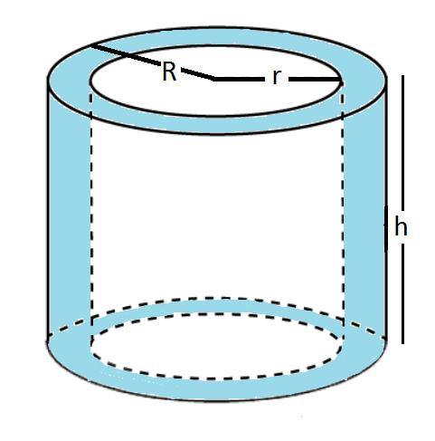
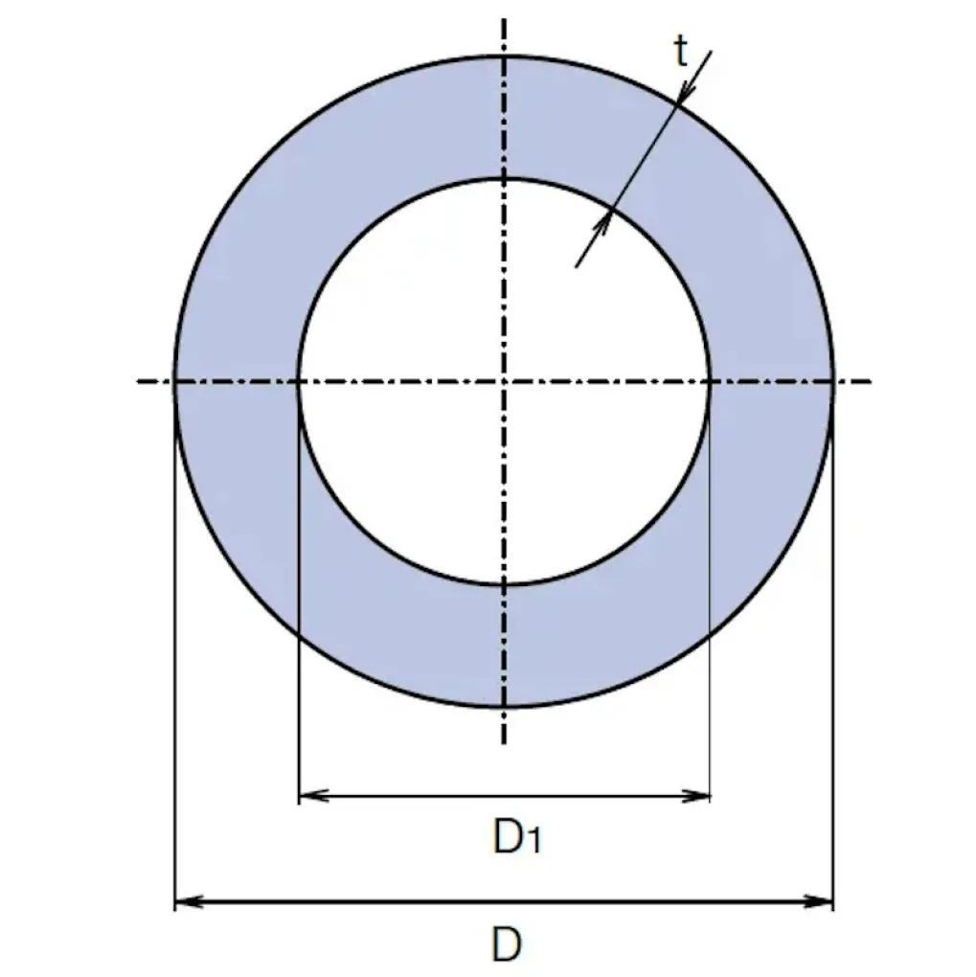
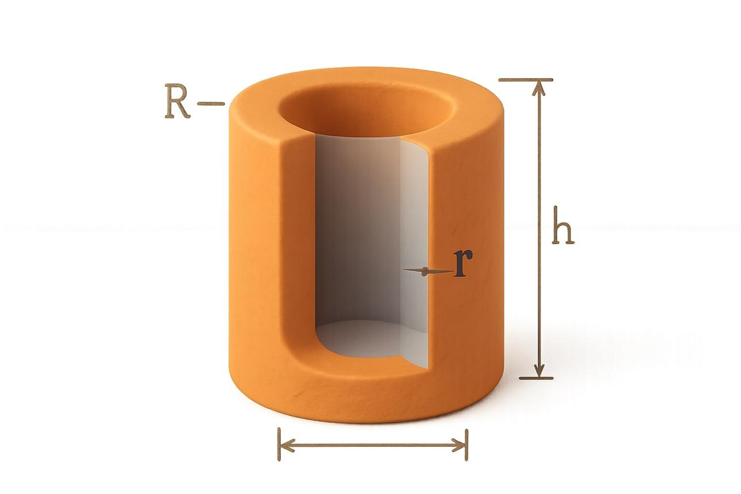

Definition
# Source: AI Source: Provided by: [Data Path: Persons Table -> ID Column: 1, Name_En Column: Motasem Essam] -> From: [ChatGPT] on [7/25/2026]
The radius of a hollow cylinder describes the radial distance from its central axis to one of its circular boundaries. A hollow cylinder has two distinct radii:
- Inner radius ($r$ or $r_{i}$): the distance from the central axis to the inner circular boundary.
- Outer radius ($R$ or $r_{o}$): the distance from the central axis to the outer circular boundary.
Therefore, the term radius of a hollow cylinder can refer to either radius, depending on the context. When both are considered together, they describe the size of the hollow opening and the thickness of the cylindrical material.

Simple Definition
# Source: AI Source: Provided by: [Data Path: Persons Table -> ID Column: 1, Name_En Column: Motasem Essam] -> From: [ChatGPT] on [7/25/2026]
A hollow cylinder has an inner radius measuring its opening and an outer radius measuring its full outside size.

Geometric Representation
# Source: AI Source: Provided by: [Data Path: Persons Table -> ID Column: 1, Name_En Column: Motasem Essam] -> From: [ChatGPT] on [7/25/2026]
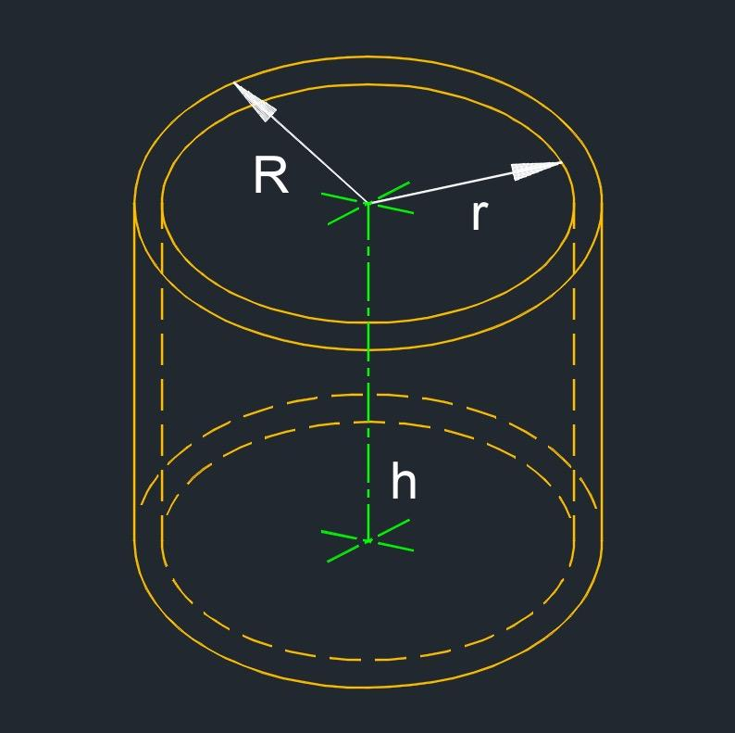
A cross-section perpendicular to the axis of a hollow cylinder forms an annulus (a ring-shaped region).
Its main measurements are:
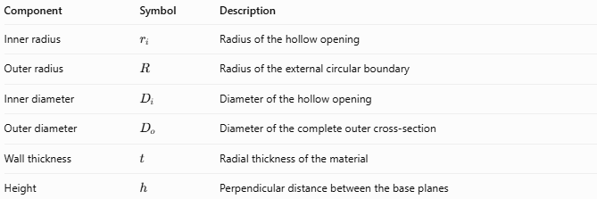
Component | Symbol | Description
Inner radius | $$r_{i}$$ | Radius of the hollow opening
Outer radius | $$R$$ | Radius of the external circular boundary
Inner diameter | $$D_{i}$$ | Diameter of the hollow opening
Outer diameter | $$D_{o}$$ | Diameter of the complete outer cross-section
Wall thickness | $$t$$ | Radial thickness of the material
Height | $$h$$ | Perpendicular distance between the base planes
The basic relationship is:
$$0≤r_{i}<R$$
For a hollow cylinder with a nonzero opening, $r_{i}>0$.

Types of Radius in a Hollow Cylinder
# Source: AI Source: Provided by: [Data Path: Persons Table -> ID Column: 1, Name_En Column: Motasem Essam] -> From: [ChatGPT] on [7/25/2026]
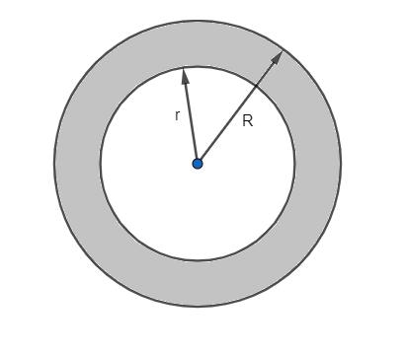

Inner Radius
# Source: AI Source: Provided by: [Data Path: Persons Table -> ID Column: 1, Name_En Column: Motasem Essam] -> From: [ChatGPT] on [7/25/2026]
The distance from the central axis to the inner wall.
$$r_{i}=\frac{D_{i}}{2}$$
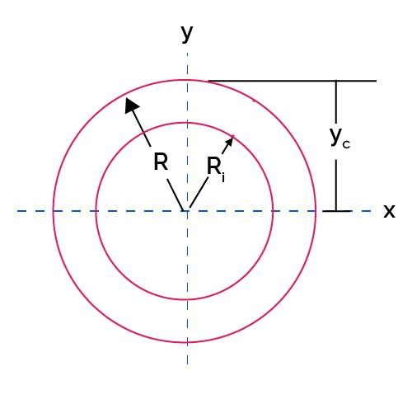

Outer Radius
# Source: AI Source: Provided by: [Data Path: Persons Table -> ID Column: 1, Name_En Column: Motasem Essam] -> From: [ChatGPT] on [7/25/2026]
The distance from the central axis to the external wall.
$$R=\frac{D_{o}}{2}$$

Wall Thickness
# Source: AI Source: Provided by: [Data Path: Persons Table -> ID Column: 1, Name_En Column: Motasem Essam] -> From: [ChatGPT] on [7/25/2026]
The difference between the outer and inner radii.
$$t=R-r_{i}$$

Mathematical Formulas

Radius from Diameter
# Source: AI Source: Provided by: [Data Path: Persons Table -> ID Column: 1, Name_En Column: Motasem Essam] -> From: [ChatGPT] on [7/25/2026]
$$\boxed{r_{i}=\frac{D_{i}}{2}} \boxed{R=\frac{D_{o}}{2}}$$

Radius and Wall Thickness
# Source: AI Source: Provided by: [Data Path: Persons Table -> ID Column: 1, Name_En Column: Motasem Essam] -> From: [ChatGPT] on [7/25/2026]
$$\boxed{R=r_{i}+t}$$
$$\boxed{r_{i}=R-t}$$

Cross-Sectional Area of the Material
# Source: AI Source: Provided by: [Data Path: Persons Table -> ID Column: 1, Name_En Column: Motasem Essam] -> From: [ChatGPT] on [7/25/2026]
The material occupies the region between the two circles:
$$\boxed{A=π\left(R^{2}-r_{i}^{2}\right)}$$

Volume of the Hollow Cylinder's Material
# Source: AI Source: Provided by: [Data Path: Persons Table -> ID Column: 1, Name_En Column: Motasem Essam] -> From: [ChatGPT] on [7/25/2026]
For a straight circular hollow cylinder of height $h$:
$$\boxed{V=πh\left(R^{2}-r_{i}^{2}\right)}$$

Inner and Outer Circumferences
# Source: AI Source: Provided by: [Data Path: Persons Table -> ID Column: 1, Name_En Column: Motasem Essam] -> From: [ChatGPT] on [7/25/2026]
$$\boxed{C_{i}=2πr_{i}}$$
$$\boxed{C_{o}=2πR}$$

Total Surface Area of a Closed-Ended Hollow Cylinder
# Source: AI Source: Provided by: [Data Path: Persons Table -> ID Column: 1, Name_En Column: Motasem Essam] -> From: [ChatGPT] on [7/25/2026]
Including both annular ends and the inner and outer curved surfaces:
$$\boxed{S=2πh\left(R+r_{i}\right)+2π\left(R^{2}-r_{i}^{2}\right)}$$
This formula assumes the cylinder has two annular end faces.

Worked Examples
# Source: AI Source: Provided by: [Data Path: Persons Table -> ID Column: 1, Name_En Column: Motasem Essam] -> From: [ChatGPT] on [7/25/2026]
Example 1: Finding both radii
Given: Outer diameter $D_{o}=20\text{ cm}$, inner diameter $D_{i}=12\text{ cm}$.
$$R=\frac{20}{2}=10\text{ cm}$$
$$r_{i}=\frac{12}{2}=6\text{ cm}$$
Answer: Outer radius $=10\text{ cm}$; inner radius $=6\text{ cm}$.
Example 2: Finding wall thickness
Given: Outer radius $R=15\text{ mm}$, inner radius $r_{i}=11\text{ mm}$.
$$t=R-r_{i}=15-11$$
Answer: $\boxed{t=4\text{ mm}}$
Example 3: Finding the material's cross-sectional area
Given: $R=8\text{ cm}$, $r_{i}=5\text{ cm}$.
$$A=π\left(8^{2}-5^{2}\right)$$
$$A=π\left(64-25\right)$$
Answer: $\boxed{A=39π{\text{ cm}}^{2}}$, approximately $122.52{\text{ cm}}^{2}$.
Example 4: Finding the inner radius from material volume
Given: $R=10\text{ cm}$, $h=12\text{ cm}$, and $V=768π{\text{ cm}}^{3}$.
Using $V=πh\left(R^{2}-r_{i}^{2}\right)$:
$$768π=12π\left(100-r_{i}^{2}\right)$$
$$64=100-r_{i}^{2}$$
$$r_{i}^{2}=36$$
Answer: $\boxed{r_{i}=6\text{ cm}}$

Comparison with Related Concepts
# Source: AI Source: Provided by: [Data Path: Persons Table -> ID Column: 1, Name_En Column: Motasem Essam] -> From: [ChatGPT] on [7/25/2026]
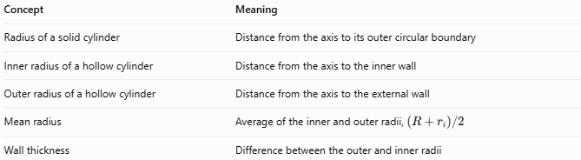
Concept | Meaning
Radius of a solid cylinder | Distance from the axis to its outer circular boundary
Inner radius of a hollow cylinder | Distance from the axis to the inner wall
Outer radius of a hollow cylinder | Distance from the axis to the external wall
Mean radius | Average of the inner and outer radii, $\left(R+r_{i}\right)/2$
Wall thickness | Difference between the outer and inner radii
Important distinction: The mean radius is a useful derived measurement, but it does not replace either the inner or outer radius.

Applications
# Source: AI Source: Provided by: [Data Path: Persons Table -> ID Column: 1, Name_En Column: Motasem Essam] -> From: [ChatGPT] on [7/25/2026]
- Pipes and tubes: determine the opening size and material thickness.
- Mechanical engineering: describe hollow shafts, sleeves, and cylindrical fittings.
- Construction: calculate the material required for cylindrical structural components.
- Fluid mechanics: determine the cross-sectional area available for fluid flow.
- Manufacturing: specify inner and outer dimensions for machining and quality control.

Key Characteristics
# Source: AI Source: Provided by: [Data Path: Persons Table -> ID Column: 1, Name_En Column: Motasem Essam] -> From: [ChatGPT] on [7/25/2026]
- A hollow cylinder generally has two distinct radii.
- The outer radius is greater than the inner radius.
- Wall thickness equals the difference between the radii.
- Material volume depends on both radii and the cylinder's height.
- All radius and thickness measurements must use consistent units.

Conclusion
# Source: AI Source: Provided by: [Data Path: Persons Table -> ID Column: 1, Name_En Column: Motasem Essam] -> From: [ChatGPT] on [7/25/2026]
The radius of a hollow cylinder is best understood by distinguishing its inner radius from its outer radius. Together, these measurements define the size of the opening, the external dimensions, and the thickness and volume of the cylindrical material.

